BIRLA INSTITUTE OF TECHNOLOGY AND SCIENCE, PILANI
BIO F242, INTRODUCTION TO BIOINFORMATICS

SECOND SEMESTER 2016 – 2017
COMPREHENSIVE EXAMINATION (CLOSED BOOK)
Full marks: 46 DATE: 03.05.17 Maximum DURATION: 2 Hrs.
- Answer to the point
- Answer all parts of same question together
- Irrelevant answer may attract penalty
- Steps in each calculation carry marks
1. a) Define following terminology related to bioinformatics: i) Alignment ii) Bit Score iii) Boot strap Analysis iv) Contig v) E-value vi) Gap penalty vii) Maximum likelihood viii) Orthologs ix) Profile x) Substitution matrix [0.5X10=5]
b) Compare the following pairs: i) Global Alignment Versus Local alignment ii) Sequence Homology Versus Sequence similarity iii) Amino acid scoring matrix Versus Nucleotide Scoring matrix iv) Ab initio based gene prediction program versus homology based gene prediction programs v) Distance based phylogenetic tree construction methods Versus Character based Tree Construction methods [1X5=5]

2. a) A researcher was trying to develop PAM250 scoring matrix from a set of related proteins and obtained the following table (partially shown). From the data, comment on authenticity of this scoring matrix. Justify your answer. [2]

 | N | D | E | Q
M | 6 | 5 | 6 | 9
I | 2 | 2 | 2 | 6
L | 4 | 6 | 4 | 5
V | 2 | 5 | 4 | 4

b) Suggest two different scoring schemes by which you can obtain following two optimal alignment. Justify. [2]
i) GAAT T T C ii) GAATTTC
C –A –T – C CA– – –TC

c) The following two are PAM1 matrices of two evolution models. Explain these models and derive one of these models from basic assumptions. Mention basic assumptions of PAM matrix development. [1+2+1]
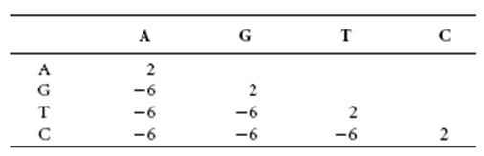
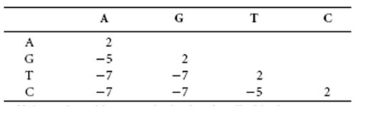

d) How do you justify that the observed sequence alignment can occur by random chance or the alignment is indeed provide the evidence of homology? [2]

3. a) Explain each term of following expression and use of each of the expression. [1.25X4=5]
i) Expression of Propensity
P_{ij} = n_{ij}/n_{i} ÷ ∑ n_{ij} / ∑ n_{i}
ii) Expression of minimum entropy score
S(m_{i}) = -∑C_{i}ª log (p_{ia})
iii) Expression of maximum-likelihood
Pr(D|T,M)= Π_{i} Pr(D_{i}|T,M)
iv) Expression of BLOSUM log-likelihood
S_{ij} = 2log₂[p_{ij}/(p_{i}p_{j})]
b) Use following two sequence and establish that DOT plot and DP (Needleman-Wunsch) method reveal two different types of information regarding this pair of sequences. [1+3+1]
Sequence 1: AWAPQW
Sequence2: PPAW
[Use BLOSUM62 as a scoring matrix and -2 as gap penalty]

3.a) You are asked to perform multiple sequence alignment of certain DNA region of 10 organisms with CLUSTALW using a fixed scoring scheme. The rate of substitutions of that region of DNA across 10 different organisms of length 1000 bases is estimated as 10⁻⁹ per base per year. Considering that the group of organism diverged approximately 10 million years ago, what would be your choice of scoring scheme? Justify your answer. [3]
b) Explain sum of pairs (SP) scoring method with example. [3]

4. a) Mention the steps of Chou-Fasman method of protein secondary structure prediction. What could be possible reasons for Chou-Fasman 3-state prediction accuracy of 50-60%? [2+1]
b) “Every homology model contains errors”. What are the two major sources of errors? Explain. How one can validate the quality of homology modeled structure? [1+2]
c) Explain the statement “Loop modeling is like mini protein structure prediction problem.” [2]
d) What are the meaning of sensitivity (Sn) and specificity (Sp) in gene prediction accuracy? [2]

*********************************Good Luck***********************************

BLOSUM62 Substitution matrix
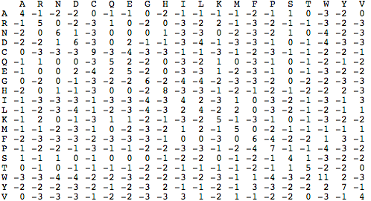

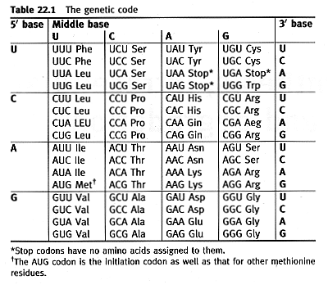

BIRLA INSTITUTE OF TECHNOLOGY AND SCIENCE, PILANI
BIO F242, INTRODUCTION TO BIOINFORMATICS

SECOND SEMESTER 2016 – 2017
COMPREHENSIVE EXAMINATION (OPEN BOOK)
Full marks: 24 DATE: 03.05.17 DURATION: 1 Hr.
- Answer to the point
- Answer all parts of same question together
- Irrelevant answer attract penalty
- Steps in each calculation carry marks
1. a) From the given multiple sequence alignment of part of protein B sequence of four species construct best phylogenetic tree using NJ method. Show entire analysis. Identify root of this tree and mention all branch length of the rooted tree. In which way, NJ method is superior over UPGMA tree. [5+1+1]
Taxa-1 ACGCGTTGTGCGATGGCAAC
Taxa-2 ACGCGTTGTGCGACGGTAAT
Taxa-3 ACGCATTGAATGATGACAAT
Taxa-4 ACACATTGAGTGATAATAAT

b) A bioinformatician wishes to find regions of sequence similarity between a newly sequenced fungal genome and an existing well-annotated fungal genome. She attempts to use the Smith-Waterman algorithm in order to align the genomic DNA from the two species. However, soon after she starts the algorithm her PC crashes and she has to abort.
Explain why you think this approach failed. Describe an alternative approach that could be used for carrying out the task more effectively. How does your alternative approach overcome the difficulties of the original method? [3]

2. a) Suppose you join in a research lab where researchers are working on whole genome annotation project. Give a research plan to annotate whole genome of newly identified bacteria from hydro thermal vent. [5]
b) If you look into nucleotide sequence database (~201 million sequences) and protein sequence database (~554 thousand sequences), you will find that there is huge mismatch in content of these two databases. Identify possible reasons for this observation. [2]
c) Explain why DNA sequence of 16S ribosomal RNA (wherever it is applicable) is always used to get information of species evolution. [2]

3.a) Identity based scoring scheme is one of the simplest scoring scheme. However it has major drawbacks. What are the drawbacks of such scoring scheme? In which type of data (dna, rna or protein) it works best and why? [2]
b) Construct MSA with following four sequences (S1 to S4) using progressive alignment technique (consider star approach). [3]

DATA:

S1 | M | Q | P | I | L | I | L | V
S2 | M | L | R | L | I
S3 | M | K | I | V | L | L
S4 | M | P | P | V | L | I | V | V

The pair-wise alignment and score (within parenthesis) of these four sequences is shown in tabular form

 | S1 | S2 | S3 | S4
S1 | - | MQPI L I LV  - - -MLR L I (9) | MQPILILV  MKIVLL- -(12) | MQP I LI LV  MP PVLIVV (27)
S2 | (9) | - | MLRLI - -  - MKIVLL (9) | - - -MLRLI  MPPVL I VV (6)
S3 | (12) | (9) | - | MKIVLL- -  MPPVLIVV (11)
S4 | (27) | (6) | (11) | -

*****************************Good Luck***************************************

